Document Template Setup
Detailed Requirements & Solution Design Document (DRSD)
Version: 1.0
Status: Draft
Module: Document Template Setup
Application: Salestar.APP.Setup
Document Type: Functional Requirements & Solution Design

1. Purpose
This document defines the functional and technical requirements for the Document Template Setup module.
The module provides a web-based HTML template management solution that allows users to create, edit, manage, preview, copy, delete and maintain document templates while remaining independent from the legacy Word/OpenOffice template solution.

2. Scope
The following functionality is included:
- Template Search
- Template List
- Template Creation
- Template Editing
- Template Copy
- Template Delete
- Template Preview
- Document Type Management
- Merge Field Management
- Multi Page Templates
- Image Management
- Default Template Management
- Active/Inactive Status Management

3. Requirement Sources
Requirements in this document were derived from:
Source 1
Implementation Design Document
<Document_Template_Setup_Implementation_Plan (2) (1).docx> [Document_T...an (2) (1) | Word]
Source 2
New Web UI Screens
- Template Search/List
- Template Add/Edit
Source 3
Implementation Code
- TemplateList.cshtml
- TemplateAddEdit.cshtml
- DocumentTemplateList.js
- DocumentTemplateAddEdit.js
Source 4
Legacy Application
Used only for merge field identification.

4. Solution Architecture
Plain Text
1
User
2
↓
3
MVC View
4
↓
5
MVC Controller
6
↓
7
API Controller
8
↓
9
Service Layer
10
↓
11
Stored Procedures
12
↓
13
Database
14

Show more lines

5. Screen Specification

5.1 Template Search Screen
Purpose
Allows users to search and maintain document templates.
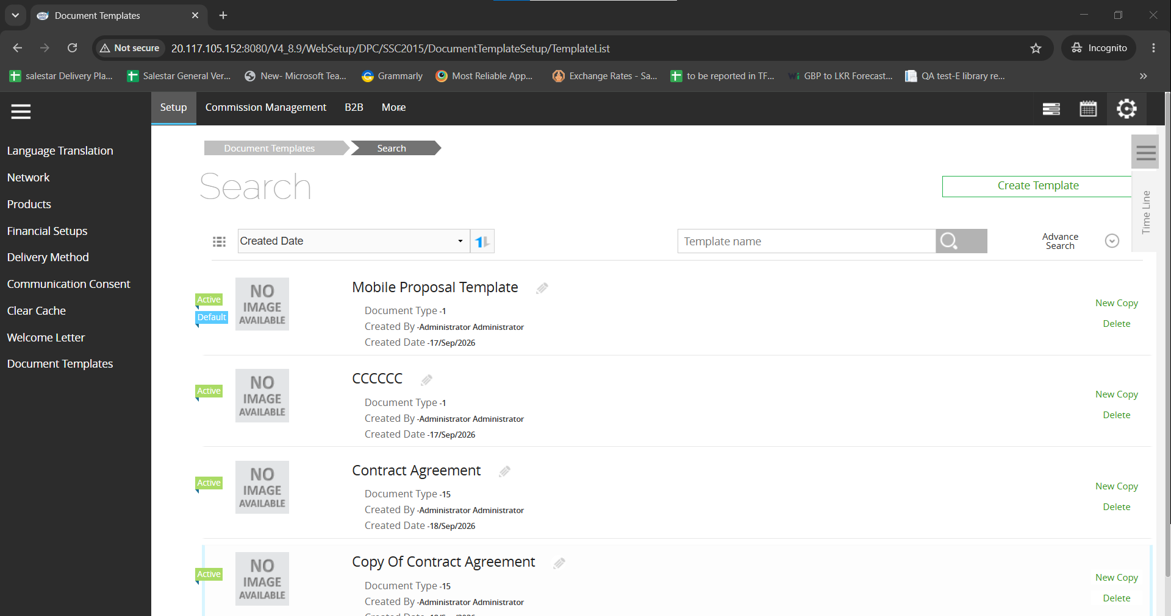

Available Controls
Create Template
Requirement:
DTS-001
The system shall allow the user to create a new template.
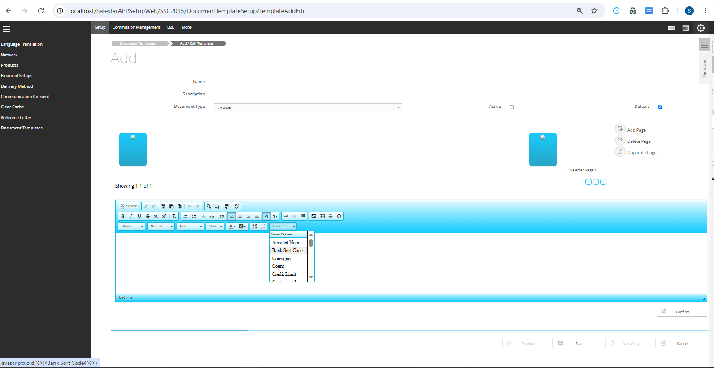

Search Box
Requirement:
DTS-002
The system shall allow users to search templates using Template Name.

Search Button
Requirement:
DTS-003
The search shall execute when Search button is clicked.

Enter Key Search
Requirement:
DTS-004
The search shall execute when Enter key is pressed.

Sort Dropdown
Available Values:
Plain Text
1
Created Date
2
Created By
3
Template Name
Show more lines
Requirements
DTS-005
Sort by Created Date
DTS-006
Sort by Created By
DTS-007
Sort by Template Name

Sort Direction
Requirement
DTS-008
Ascending and Descending sorting shall be supported.

Advanced Search
Requirements
DTS-009
Advanced Search panel shall be expandable.
DTS-010
Advanced Search panel shall be collapsible.

Advanced Search Filters
Template Name
DTS-011
Filter by Template Name.
Created By
DTS-012
Filter by Created By.
Document Type
DTS-013
Filter by Document Type.
Active Only
DTS-014
Filter by Active templates.
Default Only
DTS-015
Filter by Default templates.

5.2 Search Results Section
Each result shall display:
- Thumbnail
- Template Name
- Document Type
- Created By
- Created Date
- Active Status
- Default Status
Requirements
DTL-001 through DTL-006

Edit
DTL-007
Pencil icon opens Edit screen.

New Copy
DTL-008
New Copy shall create a copy of the selected template.

Delete
DTL-009
Delete shall remove the template after confirmation.

5.3 Template Add/Edit Screen
Purpose:
Maintain document templates.

Name
Requirement
DTM-001
Template Name is mandatory.
Maximum length:
50 characters

Description
Requirement
DTM-002
Description is optional.
Maximum length:
100 characters

Document Type
Requirement
DTM-003
User shall select a document type.

Active
Requirement
DTM-004
Template may be active or inactive.
Default value:
True

Default
Requirement
DTM-005
Template may be flagged as default.

Preview
Requirement
DTM-006
User shall preview template output.

Save
Requirement
DTM-007
User shall save template.

New Copy
Requirement
DTM-008
User shall create copies from existing templates.

Cancel
Requirement
DTM-009
User shall discard unsaved changes.

6. Multi Page Template Requirements
Add Page
PG-001
User shall add pages.

Delete Page
PG-002
User shall delete pages.

Duplicate Page
PG-003
User shall duplicate pages.

Page Navigation
PG-004
User shall navigate between pages.

Drag & Drop Page Order
PG-005
User shall reorder pages.

Selected Page
PG-006
Selected page content shall be loaded.

Save Multiple Pages
PG-007
All pages shall persist after save.

Reload Multiple Pages
PG-008
All pages shall load after reopen.

7. Merge Field Functionality
Insert Content
MF-001
Merge fields shall be loaded based on Document Type.

Document Type Change
MF-002
Changing Document Type shall reload merge fields.

Insert Field
MF-003
Selected field shall insert at cursor position.

Save Merge Fields
MF-004
Merge fields shall persist after Save.

Reload Merge Fields
MF-005
Merge fields shall reload correctly.

8. Document Types
Supported document types:
- Invoice
- Box Label
- Kit Fund
- Accounts Statement
- Despatch Note
- Defect Order Token
- Contract Agreement
- Gift Voucher
- Credit Voucher

9. Merge Field Catalogue
Invoice (33 Fields)
Includes:
- Account Number
- Bank Sort Code
- Consignee
- Credit Limit
- Invoice Number
- Invoice Date
- Invoice Amount
- Invoice Total
- Product Code
- Product Name
- Quantity
- Customer fields
- Site fields
Data Types
- String
- Currency
- Date
- Decimal

Box Label (8 Fields)
- Barcode
- Bin Location
- GRN Date
- GRN Reference
- Location
- Part Code
- Product Name
- Quantity

Kit Fund (20 Fields)
- Company Name
- Customer Name
- Date From
- Date To
- Handset Name
- Tariff Name
- Total Kit Fund
- Outstanding Amounts
- Utilized Amounts

Accounts Statement (17 Fields)
- Account Code
- Opening Balance
- Closing Balance
- Debit Amount
- Credit Amount
- Outstanding Amount

Despatch Note (21 Fields)
- Courier
- Tracking Number
- Despatch Reference
- Product Code
- Product Description
- Quantity
- Weight

Defect Order Token (25 Fields)
- Repair Fields
- Loan Product Fields
- Original Invoice Fields
- Charge Fields

Contract Agreement (26 Fields)
- IMEI
- Handset
- SIM
- Tariff
- Spend Manager
- Spend Limit
- Monthly Charges
- Customer Details

Gift Voucher (9 Fields)
- Customer Name
- Expiry Date
- Generated Date
- Photo
- Voucher Barcode
- Voucher Reference
- Voucher Value

Credit Voucher (6 Fields)
- Credit Note Reference
- Customer Name
- Expiry Date
- Generated Date
- Voucher Barcode
- Voucher Value

10. Validation Rules
Name Required
VAL-001
Template Name mandatory.

Invalid Characters
VAL-002
Not allowed:
Plain Text
1
\ / : * ? " < > |
Show more lines

Reserved Names
VAL-003
Not allowed:
Plain Text
1
CON
2
PRN
3
NUL
4
COM1
5
LPT1
Show more lines

Length Validation
VAL-004
Name max:
Plain Text
1
50
Show more lines
VAL-005
Description max:
Plain Text
1
100
Show more lines

11. Default Template Rules
DEF-001
Only one Default template may exist per document type.

DEF-002
Default replacement confirmation shall be displayed.

DEF-003
No-default scenario confirmation shall be displayed.

12. Image Requirements
IMG-001
User shall upload images.
IMG-002
Images shall be embedded in templates.
IMG-003
Images shall persist after save.
IMG-004
Images shall persist after copy.

13. API Requirements
- GetCustomizableReportTypes
- GetCustomizableReportFields
- DocumentTemplateList
- CustomizableTemplateDetailGet
- SelectedTemplatePageDetailsGet
- SaveCurrentPageDetails
- UpdatePageContentWithAction
- CustomizableTemplateSave
- DeleteDocumentTemplate

14. Business Rules
BR-001
Active defaults to True.
BR-002
Preview unavailable until template saved.
BR-003
Copy prefixes template with:
Plain Text
1
Copy Of
Show more lines
BR-004
Copy creates a new TemplateID.
BR-005
Merge fields depend on selected Document Type.

15. Traceability Matrix
Requirement Group | Source
DTS | Template Search Screen + TemplateList.cshtml
DTL | Template Search Screen + TemplateList.cshtml
DTM | Template Add/Edit Screen + TemplateAddEdit.cshtml
PG | TemplateAddEdit.cshtml + DocumentTemplateAddEdit.js
MF | Legacy Merge Fields + DocumentTemplateAddEdit.js
DEF | DocumentTemplateAddEdit.js
API | DocumentTemplateList.js + DocumentTemplateAddEdit.js

16. QA Risks
High Risk Areas:
- Merge Field Loading
- Document Type Switching
- Multi Page Persistence
- Default Template Rules
- Copy Functionality
- Image Management
- Preview Generation

